**API TESTING**

Contents

**What is API?** 2

**What is API Testing?** 3

**What is REST API?** 3

Difference between REST API vs SOAP API. 4

What to Test in API Testing? 5

Why you should perform API Testing? 5

**HTTP – Fundamental**

What is Authentication?

**HTTP Methods**

* HTTP GET Method
* HTTP POST Method
* HTTP PUT Method
* HTTP PATCH Method
* HTTP DELETE Method

**API Testing TOOLS**

* Postman
* Katalon

**How to perform API Testing using Postman**

# **What is API?**

API stands for the Application Programming Interface; they are basically a collection of functions and procedures which allows us to communicate two application or library. For example, It like a connector as seen in the picture. All data connects to our organization through API.

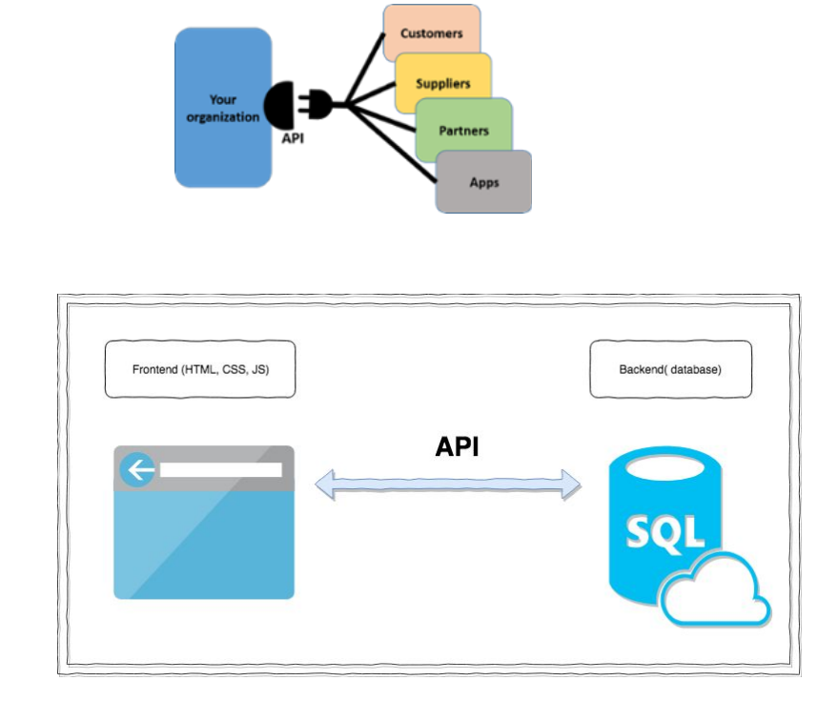

Example:

Suppose you go to restaurant

API is the messenger that takes your order(waiter) and tells the system(kitchen) what to do (to prepare food) and in return gives back the response you asked for (waiter returns with the ordered food).

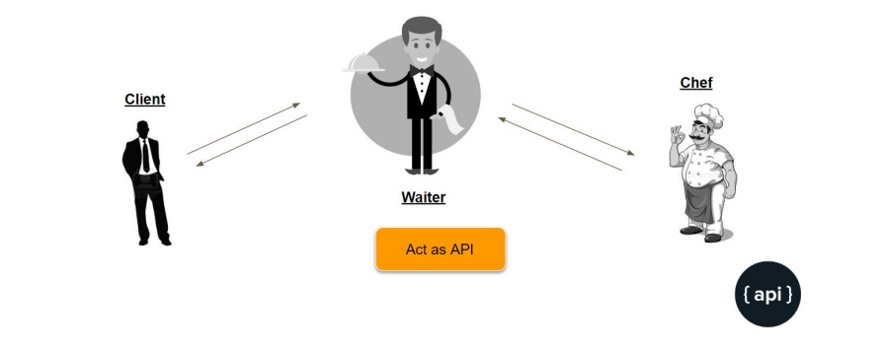

# **What is API Testing?**

When we talk about API Testing, API testing is testing that APIs and its integration with the services.

It is one of the most challenging types of testing, If we miss the certain cases in API Testing that can cause a very big problem in production after full integration and it will hard to debug in production environment.

In this definite guide, We are basically discussing about the REST API Testing. Where we need to test the REST APIs for the validation, error codes and load testing.

# **What is REST API?**

As REST is an acronym for representational State Transfer, statelessness is key. An API can be REST if it follows the below constraints.

The REST architectural style describes six constraints. These constraints, put on the architecture, were initially communicated by Roy Fielding in his doctoral dissertation and defines the basis of RESTful-style.

1. Uniform Interface

2. Stateless

3. Cacheable

4. Client-Server

5. Layered System

6. Code on Deman

**Uniform Interface**

The uniform interface constraint defines the interface between clients and servers. In other terms, First constraint of the REST API states that the Client and server has to communicate and agree to certain rules based on resources(they should communicate with same resource like json, xml, html , txt) and with proper encoding like UTF-8 extra. Another point they should communicate with the Self-descriptive Messages e.g Use the same MIME types.

**Stateless**

APIs in REST are stateless and Client and server doesn’t worry about the state of the request or response.

**Cacheable**

According to the World Wide Web, clients can cache responses. Responses should therefore, implicitly or explicitly, define themselves as cacheable. Its upto server when they want the cache to expired etc.

**Client-Server**

Client and Server are two different entity, It means that servers and clients may also be replaced and developed independently, as long as the interface is not altered.

**Layered System**

It means that the between client and server there can be any number of layered systems it does not matter.

**Code on Demand**

Server can store the Code or logic to themselves and transfer it whenever needed rather client side logic. If any API fulfil all the constraints then we can it REST API.

# Difference between REST API vs SOAP API.

We have already discussed REST API , Lets now Learn what is SOAP API.

SOAP (Simple Object Access Protocol) is a messaging protocol that allows programs that run on disparate operating systems or services like frontend or backend to communicate using Hypertext Transfer Protocol (HTTP) and its Extensible Markup Language (XML).

SOAP uses WSDL is an XML format for describing network services as a set of endpoints operating on messages containing either document-oriented or procedure-oriented information.

# What to Test in API Testing?

● Validate the keys with the Min. and Max range of APIs (e.g maximum and minimum length)

● Have a Testcase to do XML,JSON Schema validation.

● Keys verification. If we have JSON, XML apis we should verify it's that all the keys are coming.

● Verify that how the APIs error codes handled.

# Why you should perform API Testing?

Many of the services that we use every day rely on hundreds of different interconnected APIs, if any one of them fails then the service will not work.

Right now, Internet uses millions of APIs and they should be tested thoroughly. Developers make mistake and they create buggy APIs. Validation of APIs is very important which are going live to production.

